-- CREATE database MYPROJECTS;

use MYPROJECTS;

-- Task 1: Creating Table Employee1

create database test;

use test;

show tables;

create table employes(Employeeid int(35),firstname varchar(50),lastname varchar(50),Department varchar(40),salary int(50),managerId int(40));

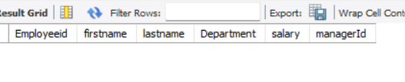

-- Task 2: Inserting Data into Employee1 table

insert into employes values('1','archana','aa','cse','25000','50'),('2','Rachana','rr','IT','55000','20'),('2','Chaithu','cc','EEE','56000','7'),('3','Madhu','mm','AIML','63000','8'),('4','Thrush','tt','Ds',70000,'9');

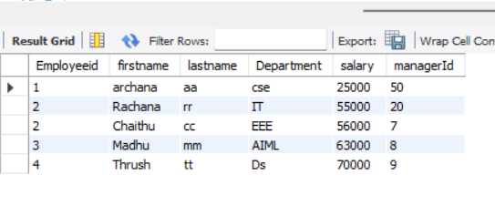

-- Task 3: Select with WHERE

-- Retrieve the names and salaries of employees whose salary is greater than 50000.

SELECT firstname,salary from employes where salary>50000;

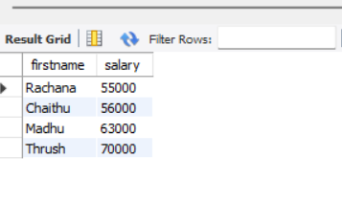--

Task 4: Select with AND

-- Retrieve the first and last names of employees whose salary is between 40000 and 60000.

select firstname,lastname from employes where salary Between 40000 And 60000;

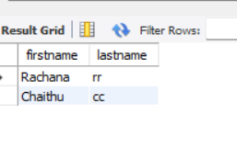

-- Task 5: Select with NOT

-- Retrieve the first and last names of employees whose salary is not equal to 55000.

select firstname,lastname from employes where salary !=55000;

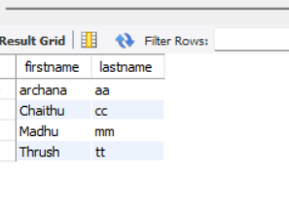

-- Task 6: Order By

-- Retrieve the first and last names of all employees, ordered by their salary in descending order.

select firstname,lastname from employes order by salary desc;

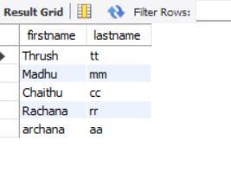

-- Task 7: Select with OR

-- Retrieve the first and last names of employees whose salary is either less than 45000 or greater than 60000.

select firstname,lastname from employes where salary<45000 or salary>60000; 